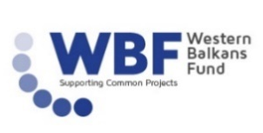
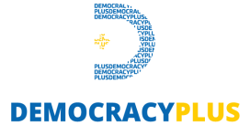

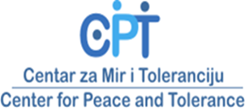
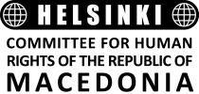


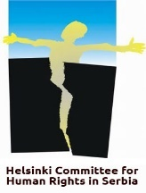

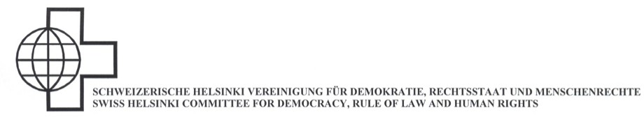

CALL FOR APPLICATIONS
SUMMER SCHOOL and PROJECT “CHALLENGE HISTORY 2 – REACT FOR THE FUTURE”
22-28 July, 2018
Prizren, Kosovo*
Deadline for Applications: 20 May 2018

The Center for Peace and Tolerance (CPT) and its project partners1 are pleased to announce the call for applications for the Summer School of “Challenge History 2 -REACT for the Future”, which will be held from 22nd to 28th July 2018 in Prizren, Kosovo* which is financially supported by the Western Balkans Fund, the Swiss Federal Department of Defence, Civil Protection and Sport, the Friedrich-Ebert-Stiftung Dialogue Southeast Europe (FES-SOE), the Schweizerische Helsinki Vereinigung and forumZFD (Forum Civil Peace Service).
We are inviting open-minded students from high schools (16-17 years old only) in Bosnia and Herzegovina (BiH), Kosovo*, Macedonia and Serbia to apply for the Summer School as part of the REACT program.
The Summer School will enable its participants to:
- Actively reflect on historical narratives, particularly those related to the recent wars/conflicts in the Balkans, in order to enable them in developing open dialogue and constructive approach dealing with past for the future
- Increase their regional network and strengthen cross-country neighbourly relations; and
- Increase their critical thinking through fun and creative activities network with young people from the region and strengthen cross-country neighbourly relations.

¹Friedrich-Ebert-Stiftung Dialogue Southeast Europe (FES-SOE), Democracy Plus (Kosovo*), The Swiss Helsinki Committee for Human Rights (Serbia), CIVIL MK – Center for Freedom (Macedonia), The Swiss Helsinki Committee for Human Rights (Macedonia), United World College (UWC) Mostar (BiH), Schweizerische Helsinki Vereinigung (SHV) and forumZFD (Forum Civil Peace Service) in BiH, Kosovo* and Macedonia
*This designation is without prejudice to positions on status and is in line with UNSC 1244 and the ICJ Opinion on the Kosovo declaration of independence.
The Project and the Summer School “Challenge History 2 – REACT for the Future”
Young people play a crucial role in the ongoing reconciliation processes in the Western Balkans. In order to build a peaceful future and strengthen the cooperation among countries of the region, the involvement of the young generation is particularly important.
Many divisions and conflicts in the region have their origin in divisive memories and interpretations of the recent past. For this very reason, the Summer School “Challenge History 2 - REACT for the Future” addresses the past in order to build a better future. “REACT for the Future” means in this case “Reflection, Education, Action, Commitment, Together”. The starting point of this project was in 2017 when the first session of “Challenge History” was held in Mostar, BiH. Based on a successful implementation of “Challenge History 1”, the follow-up project “Challenge History 2 – REACT for the Future” was designed. It aims to encourage constructive debates on the legacies of the past among high school students from BiH, Kosovo*, Macedonia and Serbia as the four Balkan countries that still have strained relations and several unresolved disputes. By providing a supportive environment of intercultural dialogue and learning, we aim to increase awareness of youth in the Western Balkans on regional indispensability and ways to promote and develop it.
Furthermore, the “Challenge History Alumni Network Club in Europe (CHANCE)” has been created to bring together those participants who are interested in networking after the Summer School. With the support of the donors, project partners and the alumni members events, e, such as panel debates and round tables on themes like critical thinking and dealing with the past in the Western Balkans will be organized.
We believe that youth coming from these countries have an enormous potential to directly contribute in bringing the constructive change.

Information about the Summer School “Challenge History 2 – REACT for the Future”
Dates: 22 - 28 July 2018 (7 days)
Mandatory: participants will be required to attend all the sessions during the Summer School. The arrival day is 22 July by 17.00 the latest. The departure day is 28 July not before 14.00.
Place: Prizren, Kosovo*
Costs and expenses: The organizers will cover all the costs of travel, visas, accommodation and meals during the seven working days. Members of the organization staff will accompany students on their travel from the capital of their home country to Prizren and back.
Working language: English – participants must have a good working knowledge of the English language
Program: The Summer School “Challenge History 2 – REACT for the Future” will consist of the following four main modules:
- Social identity/ies
- Legacies of war/peace
- Contrasting/shared historical narratives
- Education, art and media for peace
Each module will be organized in an interactive way and be based on a variety of formats, such as lectures, workshops, field visits, debates, case studies, creative activities, production of docufiction. Distinguished experts from BiH, Kosovo*, Macedonia and Serbia will lead the modules. In addition to the program modules, cultural and evening side-events will be organised based on participants’ inputs.

Who can apply?
- Students in the second/third grade of high schools (or 16/17 years old at the time of the application submitted), and who will not have attained the age of 18 at the time of the Summer School
- Who are from BiH, Kosovo*, Macedonia or Serbia
- Who wish to learn about history of the region from an alternative multi-perspective view
- Who are willing to apply the new skills, the knowledge gained and the follow-up peace building activities in their local communities
- Who have sufficient knowledge of English language, in order to be able to interact in the sessions

How to apply?
Interested students are invited to fill in the application form (see below) accompanied with the parental signed authorization for traveling and participating at the Summer School and the Project. Together with these filled documents, the participants are expected to write a motivation letter in which the participants will:
- provide brief description on: interest, knowledge and background
- provide clear motivation to participate at the Summer School and the Project “Challenge History 2 – REACT for the Future” and explain why they believe such an initiative is important
make clear in which way they could personally and as participant contribute to the success of the Summer School and Project “Challenge History 2 - REACT for the future” and how they could be effective as a young peace builder committed in their communities as schools, youth groups, social spaces, etc.
IMPORTANT

SEND YOUR APPLICATION, MOTIVATION LETTER, SCAN OF YOUR PASSPORT, AND SCANNED PARENTAL SIGNED AUTHORIZATION TO:
Biljana Jordanovska, CIVIL
bibe.jordanovska@civil.mk

CLICK HERE TO APPLY ONLINE NOW

CLICK HERE for the Parental signed authorization

no later than 20 May 2018
A total of 28 participants will be selected according to their motivation to acquire additional knowledge, to engage in critical debates, to commit to developing and implementing follow-up peace activities after the Summer School in their communities, as well as according to gender balance and fulfilment of basic application criteria. The short-listed participants will be notified by email by 27 May 2018.

PLEASE, FEEL FREE TO CALL FOR MORE INFORMATION AT 02 / 520 91 76

THANK YOU.

The Project “CHALLENGE HISTORY 2 – REACT FOR THE FUTURE” is financially supported by the Western Balkans Fund; the Swiss Federal Department of Defence, Civil Protection and Sport; the Friedrich-Ebert-Stiftung Dialogue Southeast Europe (FES-SOE); the Schweizerische Helsinki Vereinigung and forumZFD (Forum Civil Peace Service.

